SOC L1 Alert Reporting - Lab Report

Date: 30/06/2026
Difficulty: Easy
Category: SOC Team Internals
Platform: TryHackMe

Overview

This lab reviews alert reporting and how to successfully report an alert and know when to escalate it to a level 2 SOC analyst. It also includes which information you need to include in the reports and what to do in crisis situations.

2. What I did

During or after an alert triage, level 1 analysts could be unsure about how to classify the alert which requires senior support. Alert reporting is important for true positive which need escalation. Depending on the alert severity the alert comment could be short or long and detailed to give all evidence. Alert escalation is when alerts are escalated to level 2 analysts for further review and they can read your alert comment to give them initial context and help speed up the process. Communication is key as you may need to communicate to other departments during or after analysis such as asking HR who the new employees are.

Alert reporting is important as it provides context when alerts are escalated and handed over to someone else, it records alerts indefinitely instead of raw SIEM logs which are only stored for 3-12 months and finally it improves investigation skills as you need to understand it to write it clearly. It is advised to use the 5 W’s – who, what, when, where and why for report writing on alerts.

- Who: which user logs in, runs the command or downloads file
- What: what event sequence was performed
- When: when did the event start and finish
- Where: which device, IP or website was involved
- Why: the reasoning for your verdict

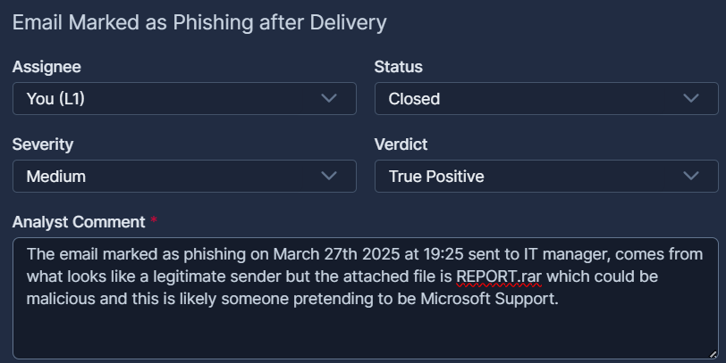

Once you have decided on a verdict and written an alert report, you need to decide whether to escalate the alert to SOC analyst level 2. It is advised to escalate the alert if it is an indicator of a major cyberattack, remediation such as malware removal or password resets are required, communication with customers, management or law enforcement is needed or just if you don’t fully understand the alert and need help from senior analysts. In most cases, all you have to do is reassign the alert to the level 2 analyst on shift and contact them to inform them.

In the worst-case scenario situations, the SOC team will have its own crisis communication procedures which are the guides and processes to help resolve issues. TryHackMe gives the following examples to refer to:

- You need to escalate an urgent, critical alert, but L2 is unavailable and does not respond for 30 minutes.
Ensure you know where to find emergency contacts. First, try to call L2, then L3, and finally your manager.
- The alert about Slack/Teams account compromise requires you to validate the login with the affected user.
Do not contact the user through the breached chat - use alternative contact methods like a phone call.
- You receive an overwhelming number of alerts during a short period of time, some of which are critical.
Prioritise the alerts according to the workflow, but inform your L2 on shift about the situation.
- After a few days, you realise that you misclassified the alert and likely missed a malicious action.
Immediately reach out to your L2 explaining your concerns. Threat actors can be silent for weeks before impact.
- You can not complete the alert triage since the SIEM logs are not parsed correctly or are not searchable.
Do not skip the alert - investigate what you can and report the issue to your L2 on shift or SOC engineer.

3. What I’ve learned

- How to report alerts
- Which details need to be included in an alert report
- How and when to escalate an alert
- What to do in crisis situations

